The Modern Advanced Find

The release of Dynamics 365 Wave 2 in October 2022, brought about a change in the experience of the advanced find.
The new modern advanced find is enabled by default. Gone is the familiar funnel icon of the advanced find that users have used for many years. The new experience allows users run advanced queries and manage views in a more user-friendly manner.
As an administrator the modern advanced find can be disabled in the Power Platform Admin Centre (https://admin.powerplatform.microsoft.com/). To do this browse to correct Environment / Instance -> Settings -> Products -> Features and then turn on or off the ‘Modern advanced find in model-driven apps.
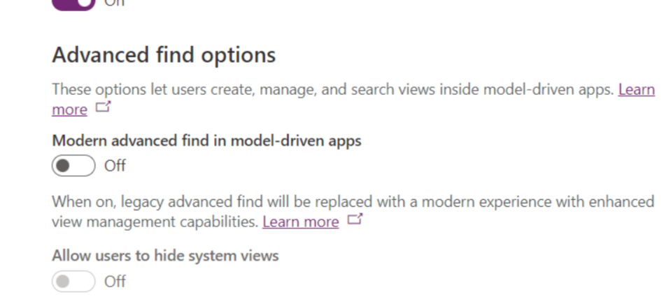

Accessing Modern Advanced Find by the Dataverse

Within the Dataverse Search box, once you click into the main area and look at the bottom you will see ‘Search for rows in a table using advanced filters’. If you click on this link it then allows you to choose the table you wish to base your query on. The tables that you can build a query on are determined by the tables in the model driven app you are logged into.
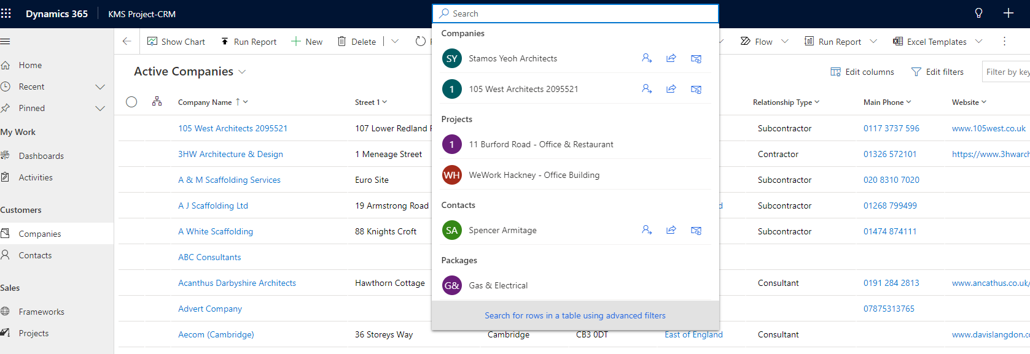

Next we might decide to select to the ‘Companies’ table to query, by clicking on the appropriate check box / radio button and then clicking Continue.
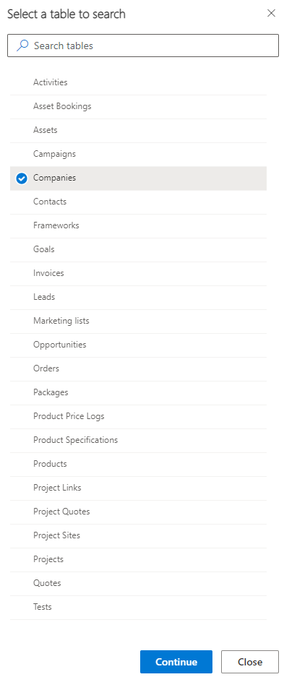
This will now open the ‘Companies’ table and the new ‘Modern Advance Find’ experience. Here we have selected the ‘Region’ column equal to ‘London’, further columns and criteria can be added by selecting the ‘+ Add’ button. A user then needs to select the ‘Apply’ button.
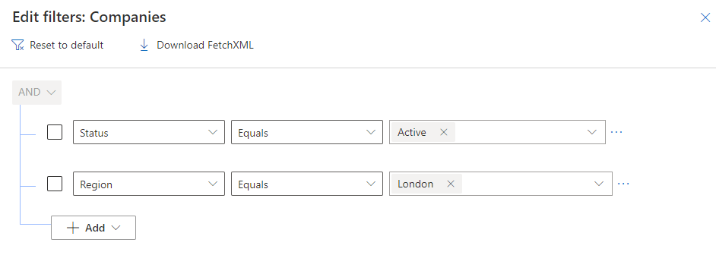
This would then take the user to the modified view they have created, and it will have an asterisk after its name.
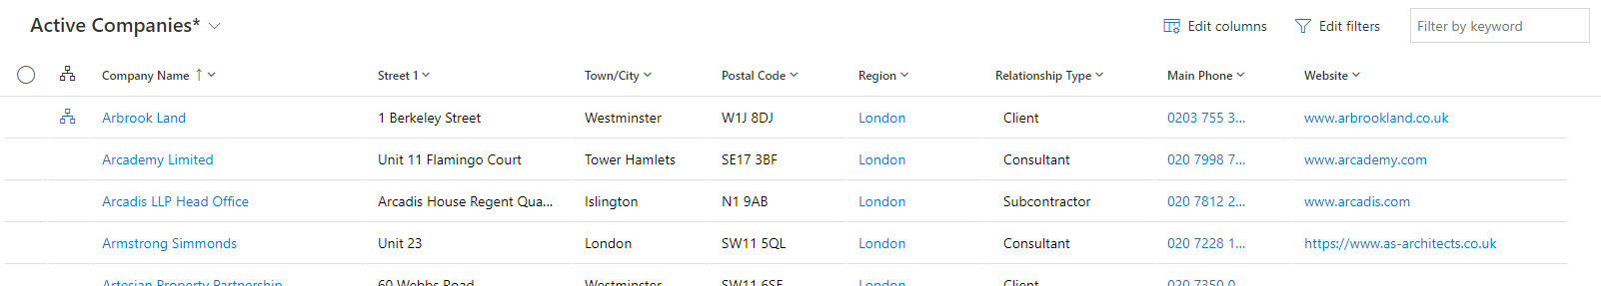
If a user wishes to further edit the view or alter the columns, they can select ‘Edit Filters’ or ‘Edit columns’ at the top.
If a user now wishes to save this view, they need to select the chevron by the view name and at the bottom of the list of views click on ‘Save as new view’.
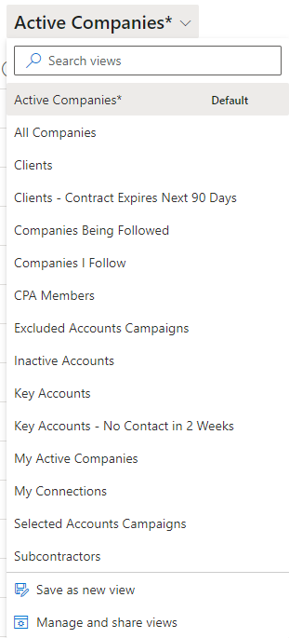
A new view name can be added for the view. Here we have named it ‘Active Companies in the London Region’. Then click ‘Save’.
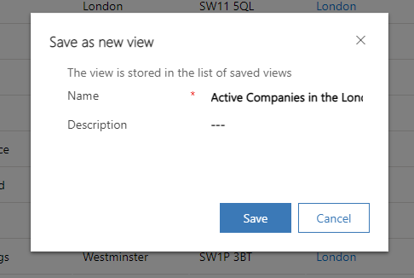
This will then show the saved view.
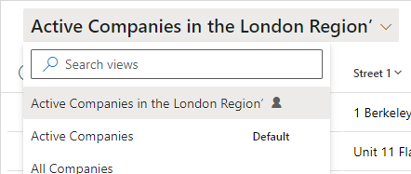
Microsoft have introduced a new way to ‘Manage and share views’. At the bottom of all the listed views you will see that option.
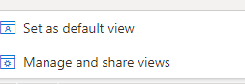
From the ‘Manage and share views’ area you can choose how to sort the views.
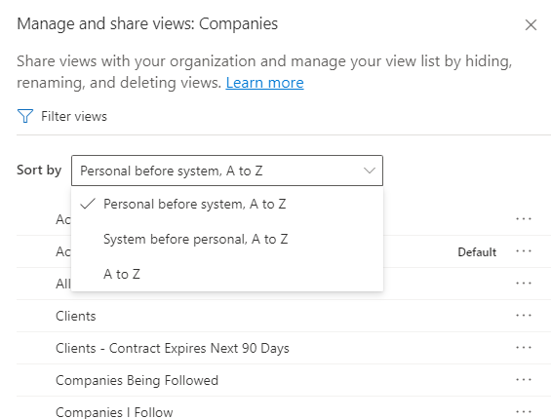
Form within the ellipses you can choose to: -
Hide, Set a view as default, Share, Edit info, Assign, Delete, Deactivate and Download the FetchXML of a view.
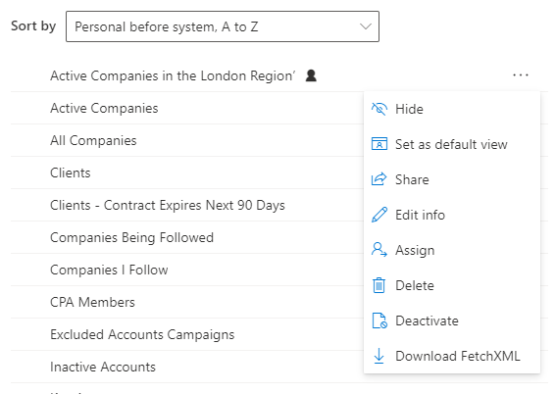

A quick way to hide a certain view or multiple views is to click to left of the view, you will see an icon appear, you then click apply.
